SEASONAL SALES ANALYSIS DASHBOARD

A PROJECT REPORT

Submitted by
VIKASH KUMAR(24BCS10326) ADITYA SENGAR(24BCS11505)
SURYA PRAKASH CHAURASIA(24BCS12150)

in partial fulfillment for the award of the degree of

BACHELOR OF ENGINEERING
IN

COMPUTER SCIENCE ENGINEERING



Chandigarh University

APRIL 2026



BONAFIDE CERTIFICATE
Certified that this project report “SEASONAL SALES ANALAYSIS DASHBOARD” is the Bonafide work of “VIKASH KUMAR,ADITYA SENGAR,SURYA PRAKASH CHAURASIA” who carried out the project work under my/our supervision.

SIGNATURE

HEAD OF THE DEPARTMENT
SIGNATURE

SUPERVISOR

INTERNAL EXAMINER EXTERNAL EXAMINER

TABLE OF CONTENTS

List of Figures 5
List of Tables 6
CHAPTER 1. INTRODUCTION 8
  - Identification of Client/ Need/ Relevant Contemporary issue 8
  - Identification of Problem 9
  - Identification of Tasks 10
  - Timeline 12
  - Organization of the Report 13
CHAPTER 2. LITERATURE REVIEW/BACKGROUND STUDY 15
  - Timeline of the reported problem 15
  - Existing solutions 16
  - Bibliometric analysis 17
  - Review Summary 18
  - Problem Definition 19
  - Goals/Objectives 19
CHAPTER 3. DESIGN FLOW/PROCESS 22
  - Evaluation & Selection of Specifications/Features 22
  - Design Constraints 25
  - Analysis of Features and finalization subject to constraints 28
  - Design Flow 31
  - Design selection 34
  - Implementation plan/methodology 38
CHAPTER 4. RESULTS ANALYSIS AND VALIDATION 39
  - Implementation of solution 39
CHAPTER 5. CONCLUSION AND FUTURE WORK 48
  - Conclusion 48
  - Future work 50
APPENDIX 52
Roles Of Team Members 54
Git Repository Link 58

List of Figures
Figure 1…………………..….DESIGN FLOW 36
Figure 2 ………………DESIGN ANALYSIS PROCES 39
Figure 3 ………………SNAPSHOT OF DATASET 40
Figure 4………………OVERVIEW DASHBOARD 41
Figure 5 …………………….….KPI CARD 42
Figure 6 ……….…..MONTHLY SALES TREND 42
Figure 7 …………SEASONAL SALES COMPARISON 43
Figure 8 ………REVENUE BY PRODUCT CATEGOERY 43
Figure 9 ………SALES DISTRIBUTION BY REGION 45
Figure 10 …..PRODUCT LEVEL ANALYSIS DASHBOARD 46
Figure 11 ……TOTAL REVENUE BY PRODUCT NAME 46
Figure 12 ……TOTAL REVENUE BY PAYMENT METHOD 47
Figure 13 …..TOTAL PRODUCT IN EACH CATEGOERY 47
Figure 14 ………….…TABLE-SALES DATA .48
Figure 15 …………SPECIFIC PRODUCT SALES 48
Figure 16 …….…GEOGRAPHICAL SALES DISTRIBUTION 67

Figure 17 ………SNAPSHOT OF REPOSITORY 48

List of Tables

Table 1……………GANTT CHART REPRESENTATION 14

Table 2 ………………COMPARITIVE ANALYSIS 20
Table 3 …………CRITICAL EVALUATION OF FEATURES 26
Table 3 …………COMPARISON OF DESIGN APPROACHES 36

ABSTRACT
In today’s data-driven world, organizations generate large volumes of data through their daily operations, particularly in the retail and e-commerce sectors. However, the true value of this data lies in its analysis and interpretation. Seasonal variations in sales significantly influence business performance, making it essential for organizations to understand patterns and trends over time. Effective analysis of seasonal sales helps businesses improve decision-making, optimize inventory, and enhance customer satisfaction.

The primary objective of this project is to analyze seasonal sales patterns using Microsoft Power BI, a powerful business intelligence and data visualization tool. The dataset used for this project has been obtained from Kaggle and contains detailed information such as product categories, product names, regions, revenue, unit prices, total units sold, and payment methods. This dataset provides a comprehensive foundation for performing multi-dimensional analysis.
The project follows a structured approach that includes data collection, data cleaning, transformation, modelling, and visualization. Power Query Editor is used to preprocess the data by handling missing values, removing inconsistencies, and creating additional columns such as month, year, and season. Data modelling is performed by establishing relationships between different fields, and DAX (Data Analysis Expressions) is used to create measures such as total revenue and total units sold.
The final output of the project is an interactive dashboard that provides insights into monthly sales trends, seasonal performance, category-wise revenue, regional distribution, and payment methods. The analysis reveals that sales vary across seasons, with certain periods generating higher revenue. It also highlights the dominance of specific product categories and regions, as well as customer preferences in payment methods.
In conclusion, this project demonstrates the effectiveness of Power BI in transforming raw data into meaningful insights. The developed dashboard enables users to analyze sales patterns efficiently and supports data-driven decision-making. This study highlights the importance of business intelligence tools in modern organizations and provides a foundation for further advancements such as predictive analytics and real-time data analysis.

CHAPTER-1 INTRODUCTION

Identification of Client /Need / Relevant Contemporary issue

In the current era of digitalization, businesses are increasingly relying on data to drive strategic decisions and improve operational efficiency. The retail and e-commerce sectors, in particular, generate vast amounts of transactional data on a daily basis. However, despite the availability of such large datasets, many organizations struggle to effectively analyze and interpret this data, especially when it comes to understanding seasonal variations in sales. This creates a significant gap between data availability and actionable insights. The issue of ineffective sales analysis is well documented in various industry reports and studies. According to multiple retail analytics studies, businesses can lose up to 20–30% of potential revenue due to poor demand forecasting and lack of data-driven strategies. Seasonal fluctuations, such as increased demand during festive periods or reduced sales during off-seasons, further complicate the problem. Without proper analysis, organizations may either overstock or understock products, leading to financial losses and reduced customer satisfaction. From a client perspective, the problem is highly relevant and requires immediate attention. The client in this scenario can be considered as a retail or e- commerce organization that seeks to improve its sales performance and decision-making process. Such organizations require a system that can provide clear insights into sales trends, identify high-performing products, and highlight seasonal patterns. Currently, many businesses rely on traditional tools such as spreadsheets, which are not capable of handling large datasets efficiently or providing interactive visualizations. This creates a need for a more advanced and user-friendly solution.

The need for seasonal sales analysis is further supported by survey-based findings. Various surveys conducted in the retail sector indicate that a majority of businesses face challenges in understanding customer demand patterns. For instance, reports suggest that over 60% of small and medium enterprises (SMEs) do not fully utilize their data for strategic decision-making. This highlights a critical need for tools that can simplify data analysis and present insights in an easily understandable format. Additionally, the relevance of this issue is evident in contemporary technological trends. Leading organizations and research agencies emphasize the growing importance of Business Intelligence (BI) tools in modern enterprises. Reports from technology firms highlight that the adoption of BI tools like Microsoft Power BI has significantly increased in recent years due to their ability to provide real-time insights and interactive

dashboards. These tools help organizations transform raw data into meaningful information, enabling better planning and forecasting. Therefore, the problem of ineffective seasonal sales analysis is not only real but also highly significant in today’s business environment. It affects organizational performance, decision-making, and overall profitability. Addressing this issue through the implementation of an Efficient data visualization and analysis system is essential for businesses to remain competitive. This project aims to fullfill this need by developing a Power BI-based dashboard that provides comprehensive insights into seasonal sales patterns.

Identification of Problem

In the modern business environment, organizations generate a vast amount of data through daily transactions, especially in the retail and e-commerce sectors. Despite the availability of such data, many organizations face significant challenges in effectively analyzing and interpreting it. One of the major issues is the inability to identify and understand patterns in sales data over time, particularly those related to seasonal variations. This lack of understanding creates a gap between data availability and meaningful insights. Seasonal fluctuations in sales are influenced by multiple factors such as festivals, holidays, weather conditions, and changing customer preferences. These variations directly impact demand for products and services. However, many businesses are unable to accurately track these fluctuations due to the absence of proper analytical frameworks. As a result, they struggle to recognize trends such as peak sales periods, low-demand seasons, and shifts in customer buying behaviour. Another critical aspect of the problem is the difficulty in managing and organizing large datasets. Sales data often consists of multiple attributes such as product categories, regions, pricing, and transaction dates. Handling such complex data manually or through basic tools becomes inefficient and error-prone. This leads to inconsistencies in data interpretation and limits the ability of organizations to derive accurate conclusions. Furthermore, businesses face challenges in understanding the contribution of different factors to overall sales performance.

It becomes difficult to determine which product categories are performing well, which regions are generating higher revenue, and which time periods contribute most significantly to sales. The absence of clear visibility into these aspects hinders strategic planning and decision-making. Another dimension of the problem is related to the lack of effective communication of data insights. Even when data is available, presenting it in a meaningful and understandable format remains a challenge. Traditional methods of reporting, such as static tables and basic charts, fail to convey complex patterns and relationships within the data. This limits the ability of stakeholders to interpret information and make informed decisions.

In addition, the dynamic nature of the market further complicates the problem. Customer preferences change rapidly, and businesses must adapt to these changes to remain competitive. Without a proper understanding of past sales trends and seasonal patterns, it becomes difficult to anticipate future demand or align business strategies accordingly. Overall, the broad problem can be summarized as the inability of organizations to effectively analyze, interpret, and understand seasonal sales data due to the complexity of datasets, lack of structured analysis, and limited visibility into key performance factors. This problem significantly affects business performance, decision-making processes, and the ability to respond to market changes.

Identification of Tasks
The successful completion of the Seasonal Sales Analysis project requires a systematic and well- structured approach. The entire project is divided into multiple tasks, each focusing on a specific phase of development. These tasks are carefully defined to ensure proper identification of requirements, development of the solution, and validation of results. The tasks can broadly be categorized into three major phases: Identification Phase, Development Phase, and Testing & Validation Phase.

Identification Phase
The identification phase is the initial stage of the project, where the problem and requirements are clearly understood. This phase plays a crucial role in defining the scope and direction of the project.

Key Tasks:
- Problem Understanding:
Analyze the issue related to seasonal sales and identify key challenges such as fluctuating demand and lack of trend visibility.

Requirement Analysis:
Identify what the client needs, such as sales insights, seasonal trends, and performance indicators.

Data Source Identification:
Select an appropriate dataset (Kaggle online sales dataset) that contains relevant attributes like product category, region, revenue, and date.

Defining Objectives:
Establish clear goals such as analyzing trends, identifying high-performing categories, and understanding regional performance.

Development Phase
The development phase involves building the solution using Power BI. This phase includes multiple technical tasks related to data handling, modelling, and visualization.

Key Tasks:
- Data Collection:
Import the dataset into Power BI for analysis.

Data Cleaning:
Remove duplicate records, handle missing values, and ensure data consistency using Power Query.

Data Transformation:
Create additional fields such as month, year, and season to enable time-based analysis.

Data Modeling:
Establish relationships between tables and organize the data structure for efficient querying.

DAX Calculations:
Create measures such as total revenue, total units sold, and growth percentage using DAX.

Dashboard Design:
Develop interactive visualizations including:
  - KPI Cards.
  - Line Charts.
  - Bar Charts.
  - Pie charts.

User Interface Design:
Ensure the dashboard is user-friendly, visually appealing, and easy to interpret.

Testing and Validation Phase
This phase ensures that the developed solution is accurate, reliable, and meets the project objectives.

Key Tasks:
- Data Validation:
Verify the correctness of calculations and ensure data integrity.

Performance Testing:
Check dashboard responsiveness and loading time.

Functionality Testing:
Ensure that filters, slicers, and interactions work correctly.

Result Verification:
Compare dashboard outputs with raw data to confirm accuracy.

User Testing:
Evaluate whether the dashboard is easy to understand and useful for decision-making.

Documentation and Reporting
Proper documentation is an essential part of the project. It ensures that the methodology, analysis, and results are clearly communicated.

Key Tasks:
- Preparing detailed project report
- Structuring chapters and sections
- Adding screenshots of dashboards
- Explaining visualizations and insights

Framework of the Report
The project report is organized into the following chapters:

Chapter 1: Introduction
Covers problem identification, objectives, and tasks.

Chapter 2: Literature Review
Covers problem identification, objectives, and tasks.

Chapter 3: Design Flow/ Process
Explains methodology, system design, and implementation steps.

Chapter 4: Result Analysis
Presents dashboard outputs and insights. Chapter 5: Conclusion and Future Work Summarizes findings and suggests improvements.

Timeline
The successful execution of the Seasonal Sales Analysis project requires a well-defined timeline to ensure that all tasks are completed systematically within the allocated time frame. A structured timeline helps in effective planning, monitoring progress, and ensuring timely completion of each phase of the project. For this purpose, a Gantt chart is used to represent the schedule of activities in a visual and organized manner. The project is divided into multiple phases, including data collection, data preprocessing, development, testing, and documentation. Each phase is assigned a specific duration based on its complexity and importance.

Project Timeline Description
The project begins with the data collection phase, where the dataset is obtained from Kaggle. This phase typically requires 1–2 days to understand the dataset structure and attributes. The next phase is data cleaning and preprocessing, which involves removing missing values, correcting inconsistencies, and transforming data into a suitable format. This phase is crucial and requires approximately 2–3 days. Following this, the data modelling and development phase is carried out. In this phase, relationships between data fields are established, and DAX measures are created. Additionally, dashboards are designed using various visualizations such as charts and graphs. This phase takes around 4–5 days as it involves both technical and design aspects. The testing and validation phase ensures that the dashboard is accurate and functions correctly. It includes verifying calculations, testing filters and slicers, and ensuring data consistency. This phase requires 2–3 days. Finally, the documentation phase is completed, where the project report is prepared, including all chapters, explanations, and screenshots. This phase usually takes 5–7 days as it involves detailed writing and formatting.

Table 1 Gantt Chart Representation

Task | Duration | Week
Data Collection | 1–2 days | Week 1
Data Cleaning & Preprocessing | 2–3 days | Week 1
Data Modelling | 2 days | Week 2
Dashboard Development | 3 days | Week 2
Testing & Validation | 2–3 days | Week 3
Report Writing & Documentation | 5–7 days | Week 3

Organization of the Report
Give The project report titled “Seasonal Sales Analysis using Power BI” is systematically organized into multiple chapters to ensure a clear, logical, and comprehensive presentation of the work carried out. Each chapter focuses on a specific aspect of the project, starting from problem identification to final conclusions and future scope. This structured approach helps readers understand the methodology, analysis, and results in a sequential manner.

Chapter 1: Introduction
This chapter provides an overview of the project by introducing the problem and its relevance in the current business environment. It includes the identification of the client and the need for the project, along with a discussion of the contemporary issues related to seasonal sales analysis.

The chapter also defines the problem statement, outlines the tasks involved in the project, presents the timeline, and explains how the report is organized. This chapter sets the foundation for the entire project. Chapter 2: Literature Review / Background Study
This chapter focuses on the theoretical background and existing research related to the problem. It discusses the evolution of sales analysis techniques and highlights various tools and methods used in the past, such as spreadsheets, traditional business intelligence tools, and advanced analytics techniques. A comparative analysis of these solutions is provided, along with their advantages and limitations. The chapter concludes by linking the findings of the literature review with the current project and clearly defining the problem and objectives.

Chapter 3: Design Flow / Process
This chapter describes the methodology adopted to develop the solution. It includes the evaluation and selection of features required for the project, along with the constraints considered during the design process. The chapter explains the data preprocessing steps, data modelling techniques, and DAX calculations used in Power BI. It also presents the design flow, including alternative approaches and the rationale behind selecting the final design. Additionally, the implementation plan and system workflow are explained in detail.

Chapter 4: Results Analysis and Validation
This is one of the most important chapters of the report, as it presents the actual outcomes of the project. It includes detailed explanations of the Power BI dashboard and its various components, such as KPI indicators, monthly sales trends, seasonal comparisons, category-wise analysis, regional distribution, and payment methods. Each visualization is interpreted to derive meaningful insights. The chapter also includes validation of results through testing and verification to ensure accuracy and reliability.

Chapter 5: Conclusion and Future Work
This chapter summarizes the overall findings of the project and evaluates whether the objectives have been successfully achieved. It highlights the key insights obtained from the analysis and discusses the impact of the project on decision-making processes. The chapter also identifies any limitations encountered during the project. In addition, it provides suggestions for future enhancements, such as incorporating predictive analytics, real-time data processing, and advanced visualization techniques.

CHAPTER-2

LITERATURE REVIEW/BACKGROUND STUDY

Timeline of the reported problem
The problem of analyzing sales data and identifying seasonal patterns has been recognized globally for several decades. With the growth of retail and e-commerce industries, understanding customer behaviour and sales trends has become increasingly important. The evolution of this problem can be traced through different stages:

Early-1990s:
During this period, businesses relied mainly on manual record-keeping and basic spreadsheet tools for sales tracking. Seasonal trends were identified through observation rather than systematic analysis. There was limited use of data for decision-making.

2000–2010:
The introduction of database management systems and enterprise resource planning (ERP) tools allowed organizations to store and manage large volumes of sales data. However, analysis was still limited to static reports, which lacked interactivity and real-time insights.

2010–2020:
The emergence of Business Intelligence (BI) tools such as Microsoft Power BI, Tableau, and Qlik transformed the way businesses analyze data. These tools enabled interactive dashboards, allowing users to visualize trends and patterns more effectively. Seasonal sales analysis became more structured and data-driven.

2020–Present:
With advancements in data analytics, artificial intelligence, and cloud computing, organizations now use advanced tools for predictive analysis and real-time monitoring. Seasonal sales analysis has become critical for inventory management, marketing strategies, and revenue optimization.
According to industry reports, organizations that fail to analyze sales trends effectively may experience up to 20–30% loss in revenue due to poor forecasting and planning. This highlights the importance of using modern tools to analyze seasonal sales patterns.

Existing solutions
Over the years, several approaches have been developed to analyze sales data and identify trends. These solutions vary in complexity, usability, and effectiveness.

Spreadsheet-Based Analysis (Microsoft Excel)
Spreadsheet tools have been widely used for analyzing sales data.

Applications:
  - Data entry and storage
  - Pivot tables and charts
  - Basic calculations

Advantages:
  - Easy to use
  - Widely available
  - Suitable for small datasets

Limitations:
  - Not scalable for large datasets
  - Limited interactivity
  - Manual effort required

Traditional Business Intelligence Tools
Tools such as Tableau, QlikView, and SAP BusinessObjects are used for advanced data visualization.

Applications:
  - Dashboard creation
  - Data visualization
  - Reporting

Advantages:
  - High-quality visualizations
  - Better performance

Limitations:
  - Expensive
  - Requires technical expertise

Machine Learning-Based Systems
Machine learning models are used for predictive analysis.

Applications:
  - Demand forecasting
  - Customer behaviour prediction

Advantages:
  - High accuracy
  - Handles large datasets

Limitations:
  - Complex implementation
  - Difficult to interpret

Power BI (Selected Approach)
Power BI is a modern business intelligence tool used for interactive data visualization.

Applications:
  - Dashboard creation
  - Real-time reporting
  - Data transformation

Advantages:
  - User-friendly
  - Cost-effective
  - Interactive

Limitations:
  - Limited advanced analytics
  - Requires DAX knowledge

Bibliometric analysis
Bibliometric analysis involves evaluating existing research and solutions based on key parameters such as features, effectiveness, and drawbacks.

Key Features Identified
- Data visualization
- Trend analysis
- Interactivity
- Data modelling
- Dashboard creation

Effectiveness of Existing Solutions
- Excel is effective for small datasets but lacks scalability
- BI tools provide better visualization and insights
- Machine learning offers predictive capabilities

Drawbacks Identified
- Complexity of advanced tools
- Lack of real-time insights
- High cost of some BI tools
- Limited accessibility for non-technical users

Table 2 Comparative Analysis

Feature | Excel | Tableau | Power BI | ML Model
Ease of use | High | Medium | High | Low
Cost | Low | High | Medium | High
Interactivity | Low | High | High | Medium
Scalability | Low | High | High | High

The analysis shows that while each tool has its strengths, Power BI provides the best balance between usability, cost, and functionality.

Review Summary
From the literature review, the following conclusions are drawn:
- Seasonal sales analysis is essential for business growth
- Traditional methods are insufficient for modern data needs
- Advanced tools improve decision-making
- Visualization plays a key role in understanding data.

Link to Current Project
This project builds upon the findings of the literature review by:
- Using Power BI for data visualization
- Creating an interactive dashboard
- Analyzing seasonal sales patterns
Thus, the project aims to provide a practical solution for understanding sales trends.

Problem Definition
Based on the literature review, the problem is defined as:
The inability of organizations to effectively analyze seasonal sales data and identify patterns due to lack of proper visualization tools and structured analysis.

What is to be Done
- Analyze sales dataset
- Identify seasonal trends
- Create visualizations

How it is to be Done
- Use Power BI
- Apply data preprocessing
- Create dashboards

What is NOT to be Done
- No machine learning prediction
- No real-time data integration
- No modification of dataset beyond cleaning

Goals/Objectives

The goals and objectives of the Seasonal Sales Analysis using Power BI project are defined to provide clear direction and measurable outcomes throughout the course of the project. These objectives are carefully designed to be specific, precise, tangible, and achievable, ensuring that the project remains focused and aligned with its intended purpose.

Primary Objectives:

The primary objectives of this project focus on analyzing sales data and extracting meaningful insights through visualization:

To analyze seasonal sales trends:
Study how sales vary across different months and seasons to identify patterns and fluctuations in demand.

To develop an interactive Power BI dashboard:
Design and implement a user-friendly dashboard that allows users to explore data dynamically using filters and slicers.

To identify high-performing products and categories:
Determine which product categories and individual products contribute the most to total revenue.

To analyze regional sales performance:
Evaluate how sales vary across different geographical regions and identify key markets.

To examine customer payment behaviour:
Analyze different payment methods to understand customer preferences and transaction patterns.

Secondary Objectives:
- These objectives support the primary goals and enhance the overall quality of the project:

To perform data cleaning and preprocessing:
Ensure that the dataset is accurate, consistent, and suitable for analysis.

To apply data modelling techniques:
Establish relationships between different data fields and create calculated measures using DAX.

To create meaningful and effective visualizations:
Use charts such as line graphs, bar charts, and pie charts to represent data clearly.

To improve data interpretation skills:
Develop the ability to interpret visual data and derive actionable insights.

Measurable Outcomes:
The objectives of the project are designed to be measurable and verifiable through the following outcomes:
  - Successful creation of an interactive dashboard with multiple visualizations.
  - Accurate calculation of key performance indicators (KPIs) such as total revenue and units sold.
  - Identification of seasonal patterns and trends in sales data.
  - Clear representation of insights through charts and graphs.
  - Validation of results by comparing outputs with the dataset.

Characteristics of Objectives:
The objectives of this project follow the SMART criteria:
      - Specific: Focused on seasonal sales analysis and visualization
      - Measurable: Based on dashboard outputs and insights generated
      - Achievable: Can be accomplished using Power BI tools

      - Relevant: Addresses real-world business problems
      - Time-bound: Completed within the defined project timeline

CHAPTER-3 DESIGN FLOW/PROCESS

Evaluation & Selection of Specifications/Features
The development of an effective Seasonal Sales Analysis dashboard requires careful identification and evaluation of features that can provide meaningful insights. Based on the literature review and understanding of business intelligence systems, several features were identified and critically analyzed. The selection of features is guided by their relevance, usability, efficiency, and ability to support decision-making.

Identified Features from Literature
From previous studies and existing solutions, the following key features were identified:

Data visualization using charts and graphs
- Interactive dashboards
- Time-based trend analysis
- Category-wise and product-wise comparison
- Region-wise analysis
- Customer payment behaviour analysis
- KPI indicators for summary statistics
- Filtering and slicing of data
These features are commonly used in business intelligence tools to analyze large datasets and present insights in an understandable format.

Table 3 Critical Evaluation of Features

Feature | Importance | Advantage | Limitations
Data Visualization | High | Easy Interpretation of  Data | Require Proper Design
Interactivity | High | User-friendly and  dynamic | Can Increase  Complexity
Trend Analysis | High | Identifies seasonal  Patterns | Needs time-based data
Category Analysis | Medium | Product performance  insights | May Cause Clutter
Region Analysis | High | Market performance  understanding | Depends on data  availability
Payment Analysis | Medium | Customer Behaviour  Insights | Limited Impact of  Core Analysis
KPI Indicators | High | Quick Summary of  Perfommance | Limited detail
Filters/Slicers | High | Flexible Data  Exploration | Required Structured  Data

Each feature was evaluated based on its importance, advantages, and limitations.

    - Analysis of Feature Effectiveness
      - Data Visualization is essential as it converts raw data into meaningful graphical representations, making it easier to interpret complex datasets.
      - Interactivity enhances user experience by allowing dynamic filtering and exploration of data.
      - Trend Analysis is crucial for identifying seasonal patterns, which is the core objective of this project. Category and Product Analysis help in understanding which products contribute most to revenue.
      - Region Analysis provides insights into geographical performance, which is useful for business expansion strategies.
      - KPI Indicators offer a quick overview of key metrics such as total revenue and units sold.

Selected Features
- Monthly Sales Trend Analysis (Line Chart)
  - To identify variations in sales over time.

Seasonal Sales Comparison (Bar Chart)
  - To compare performance across different seasons.

Revenue by Product Category (Bar Chart)
  - To analyze contribution of each category.

Sales Distribution by Region (Pie Chart)
  - To understand geographical performance.

Product-Level Revenue Analysis (Horizontal Bar Chart)
  - To identify top-performing products.

Payment Method Analysis (Donut Chart)
  - To analyze customer transaction behaviour.

KPI Cards (Summary Indicators)
  - Total Revenue
  - Total Units Sold
  - Unit Price

Filters and Slicers
  - Region
  - Category
  - Time (Month/Year)

Justification of Selected Features
The selected features are ideal for the following reasons:
- They provide comprehensive analysis of sales data
- They support interactive exploration of data
- They are easy to understand for both technical and non-technical users
- They align with the objective of seasonal sales analysis
- They ensure efficient decision-making through clear insights

Rejected / Excluded Features
Certain features were not included due to project constraints:
- Machine learning-based prediction models
- Real-time data analytics
- Complex statistical modelling
These were excluded to maintain simplicity and focus on visualization.

Design Constraints

The design and development of the Seasonal Sales Analysis dashboard are influenced by various constraints that ensure the system is practical, ethical, and aligned with professional standards. These constraints help define the scope of the project and guide the decision-making process during implementation.

Standards Considered in the Design:
The following standards and considerations were taken into account while designing the system:

Economic Constraints
Economic constraints refer to the financial limitations associated with the project.
  - The project is developed using the free/student version of Microsoft Power BI
  - No additional paid tools or software were used
  - The solution is designed to be cost-effective and accessible Impact:
  - Limits access to advanced premium features
  - Ensures the project is feasible for academic and small-scale use

Environmental Constraints
Environmental considerations are important for sustainable system design.
  - The dashboard is completely digital, reducing the need for paper-based reports
  - Promotes eco-friendly practices by minimizing resource usage
  - No physical infrastructure or materials are required

Impact:
  - Supports sustainability
  - Reduces environmental footprint

Health and Safety Constraints
Although the project is not directly related to physical health systems, certain considerations are still important.
  - Ensures that data handling does not create any risk
  - Avoids misuse of sensitive information
  - Maintains safe digital practices Impact:
  - Protects data integrity
  - Prevents misuse of information

Ethical Constraints
Ethical considerations are critical in any data-related project.
  - Data is used without manipulation or falsification
  - Insights are presented honestly without bias
  - No misleading visualizations are created Impact:
  - Maintains credibility of analysis
  - Ensures trustworthiness of results

Social Constraints
The system must be accessible and understandable to a wide range of users.
  - Dashboard is designed for both technical and non-technical users
  - Uses simple and clear visualizations
  - Avoids complex terminology Impact:
  - Improves usability
  - Enhances user experience

Professional Constraints
The project must adhere to academic and professional standards.
  - Proper report structure is followed
  - Use of formal language and documentation
  - Inclusion of all required sections (introduction, methodology, results, etc.) Impact:
  - Ensures academic quality
  - Meets evaluation criteria

Technical Constraints
Technical limitations affect system design and implementation.
  - Dataset is static and limited in size
  - No real-time data integration
  - Limited advanced analytics capabilities Impact:
  - Restricts complexity of analysis
  - Focuses on visualization

Cost Constraints
Cost plays a major role in project feasibility.
  - Zero-cost implementation using free tools
  - No hardware or software investment required Impact:
  - Makes the project accessible
  - Suitable for students and small organizations

Political and Regulatory Constraints
Although the project does not directly involve government policies, certain general guidelines are considered:
  - No violation of data usage policies
  - Dataset is publicly available and legally usable
  - No sensitive or confidential data is used

Impact:
  - Ensures legal compliance
  - Avoids misuse of data

Overall Impact of Constraints
The above constraints collectively influence the design of the system by:
  - Defining the scope and limitations of the project
  - Ensuring ethical and responsible data usage
  - Promoting simplicity and usability
  - Maintaining cost-effectiveness
  - Aligning with academic and professional standards
Rather than restricting the project, these constraints help in creating a balanced, practical, and efficient solution that meets the objectives of seasonal sales analysis.

Analysis of Features and finalization subject to constraints

After identifying and evaluating various features in the previous section, it is essential to refine and finalize these features based on the design constraints. The constraints such as technical limitations, economic feasibility, simplicity, and usability play a crucial role in determining which features should be included, modified, or excluded. This process ensures that the final system is practical, efficient, and aligned with the objectives of the project.

Need for Feature Finalization
Although several advanced features were identified during the literature review, not all of them are suitable for implementation within the scope of this project. The goal is to design a system that is:
      - Easy to understand
      - Cost-effective
      - Technically feasible
      - Focused on visualization
Therefore, features were carefully analyzed and categorized into three groups: Removed Features, Modified Features, and Added Features.

Removed Features
Certain features were excluded due to constraints such as complexity, lack of data, or irrelevance to project objectives.

Machine Learning-Based Prediction
      - Not included due to complexity and scope limitations
      - Requires advanced programming and additional tools
      - Not aligned with visualization-focused objective

Real-Time Data Integration
    - Dataset used is static (Kaggle dataset)
    - No API or live data source available
    - Real-time systems require additional infrastructure

Complex Statistical Modelling
    - Techniques such as regression and hypothesis testing excluded
    - Difficult to interpret for non-technical users
    - Not necessary for basic trend analysis

Modified Features
Some features were adjusted to fit within the constraints while still providing meaningful insights.

Trend Analysis
    - Modified to use available time-based data (Month, Season)
    - Instead of advanced forecasting, simple trend visualization is used

Data Visualization
    - Simplified charts used instead of complex visuals
    - Focus on clarity and readability

Category and Product Analysis
    - Limited to available dataset fields
    - Focus on key categories rather than excessive breakdown

Added Features
To enhance the effectiveness of the dashboard, some additional features were introduced.

KPI Cards (Key Performance Indicators)
    - Total Revenue
    - Total Units Sold
    - Unit Price
Purpose: Provide quick summary of business performance

Seasonal Comparison
    - Comparison of sales across different seasons Purpose: Identify peak and low-demand periods

Region-Wise Analysis
    - Sales distribution by region Purpose: Understand geographical performance

Payment Method Analysis
    - Analysis of customer payment preferences Purpose: Identify popular payment methods

Filters and Slicers
    - Enable dynamic data exploration Purpose: Improve interactivity

Final Feature Set
After analysis and refinement, the final set of features includes:
  - Monthly Sales Trend
  - Seasonal Sales Comparison
  - Revenue by Category
  - Region-Wise Sales Analysis
  - Product-Level Analysis
  - Payment Method Analysis

  - KPI Indicators
  - Filters and Slicers

Design Flow
The design flow represents the systematic process followed to develop the Seasonal Sales Analysis solution. It outlines the sequence of steps required to transform raw data into meaningful insights. To ensure an optimal solution, two alternative design approaches were considered and evaluated before selecting the final implementation.

Need for Multiple Design Approaches
Considering multiple design approaches helps in:
- Comparing different methods of implementation
- Identifying the most efficient and effective solution
- Ensuring that the selected design meets project requirements In this project, two design approaches were evaluated:
- Traditional Data Analysis Approach
- Power BI Dashboard Approach (Selected) Design 1: Traditional Data Analysis Approach
  - Process Flow
- Data Collection (Kaggle dataset)
- Data Cleaning using Excel
- Manual Data Analysis
- Chart Creation using Excel
- Static Report Generation

Explanation of Steps
- Data Collection: Dataset is imported into Excel
- Data Cleaning: Missing values are handled manually
- Data Analysis: Calculations are performed using formulas
- Chart Creation: Graphs are created using Excel tools
- Report Generation: Results are presented in static format

Advantages
- Simple and easy to implement
- Requires basic tools
- Suitable for small datasets

Disadvantages
- Static and non-interactive
- Time-consuming manual work
- Difficult to analyze large datasets
- Limited visualization capabilities

Design 2: Power BI Dashboard Approach Process Flow
- Data Collection (Kaggle dataset)
- Data Import into Power BI
- Data Cleaning using Power Query
- Data Modelling
- DAX Calculations
- Visualization Creation
- Interactive Dashboard Development
- Analysis and Insights

Explanation of Steps
  - Data Import: Dataset is loaded into Power BI
  - Data Cleaning: Performed using Power Query Editor
  - Data Modelling: Relationships between fields are created
  - DAX Calculations: Measures like revenue and units sold are defined
  - Visualization: Charts such as line, bar, and pie charts are created
  - Dashboard Development: Interactive dashboard is designed
  - Analysis: Insights are derived from visualizations

Advantages
  - Interactive and dynamic dashboard
  - Easy to analyze large datasets
  - Advanced visualization capabilities
  - Supports filtering and slicing
  - Faster and more efficient analysis

Disadvantages
  - Requires knowledge of Power BI
  - Initial setup is slightly complex

Table 4 Comparison of Design Approaches

Criteria | Traditional Method | Power BI Approach
Interactivity | No | Yes
Visualization Quality | Medium | High
Ease of Analysis | Low | High
Efficiency | Low | High
Scalability | Low | High
User Experience | Basic | Advanced

Selected Design
Based on the comparison, the Power BI Dashboard Approach was selected as the final design for this project.
- Reason for Selection
- Provides interactive and dynamic analysis
- Enhances data visualization and clarity
- Supports real-time filtering and exploration
- Aligns with modern business intelligence practices
- Improves decision-making efficiency

Final Design Flow
The final design flow of the system is as follows:

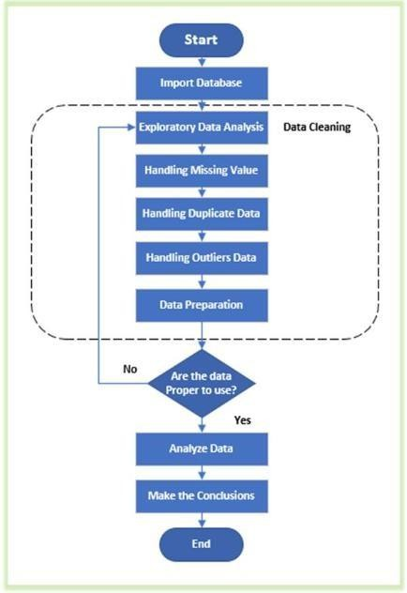
Figure 1: Design Flow

Implementation plan/methodology
The implementation plan of the Seasonal Sales Analysis project outlines the step-by-step procedure followed to transform raw data into meaningful insights using Microsoft Power BI. This methodology ensures a structured approach to data processing, visualization, and analysis.
The implementation consists of multiple stages, including data collection, preprocessing, modeling, visualization, and validation.

Step-by-Step Implementation Process Step 1: Data Collection
The dataset is obtained from Kaggle It contains attributes such as:
  - Product Category
  - Product Name
  - Region
  - Revenue
  - Unit Price
  - Total Units Sold
  - Payment Method

Purpose:
To gather relevant data required for analysis.

Step 2: Data Preprocessing
This step ensures that the dataset is clean and ready for analysis.

Tasks performed:
  - Removal of null values
  - Elimination of duplicate records
  - Correction of data types
  - Formatting of columns

Step 3: Data Transformation
Additional fields are created to support analysis:
- Month
- Year
- Season

Purpose:
To enable time-based and seasonal analysis.

Step 4: Data Modelling
- Relationships between data fields are defined
- Measures are created using DAX:
  - Total Revenue
  - Total Units Sold

Purpose:
To structure data for efficient querying and analysis.

Step 5: Visualization Creation
Various charts are created:
- Line Chart (Monthly Trend)
- Bar Chart (Category Analysis)
- Pie Chart (Region Analysis)
- Donut Chart (Payment Analysis)

Step 6: Dashboard Development
- All visualizations are combined into a single dashboard
- Layout is designed for clarity and usability
- KPI cards are added

Step 7: Interactivity Implementation
- Filters and slicers are added
- Users can explore data dynamically

Step 8: Testing and Validation
- Verify correctness of calculations
- Check functionality of filters
- Ensure consistency of data

Step 9: Analysis and Insight Generation
- Interpret graphs
- Identify trends and patterns
- Generate business insights

Flowchart
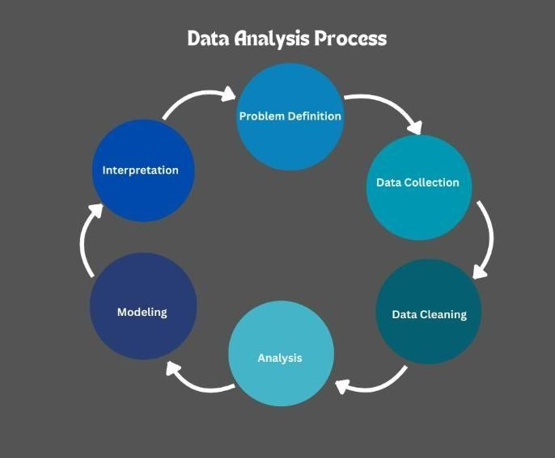
Figure 2 Design Analysis Process

Algorithm
Algorithm for Seasonal Sales Analysis
  - Start
  - Load dataset from Kaggle
  - Clean dataset (remove null and duplicates)
  - Transform data (create Month, Year, Season)
  - Create measures (Revenue, Units Sold)
  - Generate visualizations
  - Build dashboard
  - Apply filters and slicers
  - Validate results
  - Analyze data
  - End

3.6 Data Source
Link of the dataset used in the project dashboard- https://www.kaggle.com/datasets/shreyanshverma27/online-sales-dataset-popular-marketplace- data
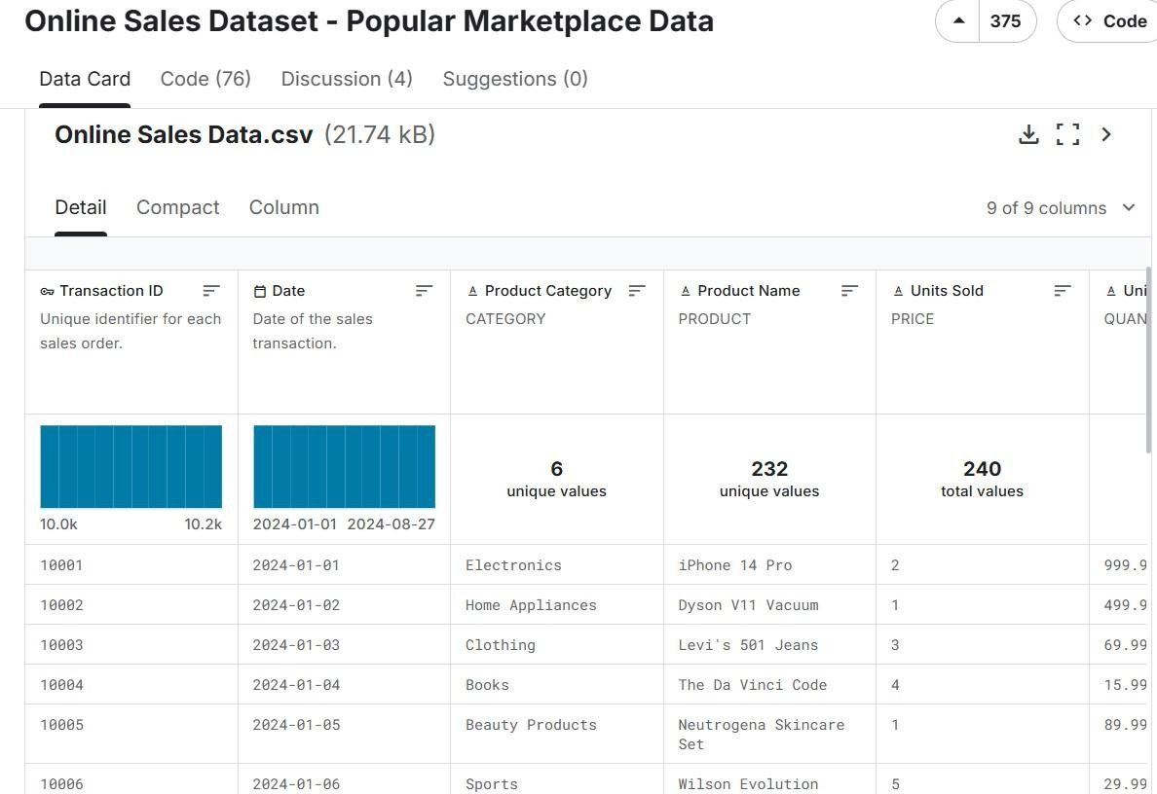
Figure 3 Snapshot of Dataset

CHAPTER-4

RESULTS ANALYSIS AND VALIDATION

Implementation of solution
Page 1 – Overview Dashboard
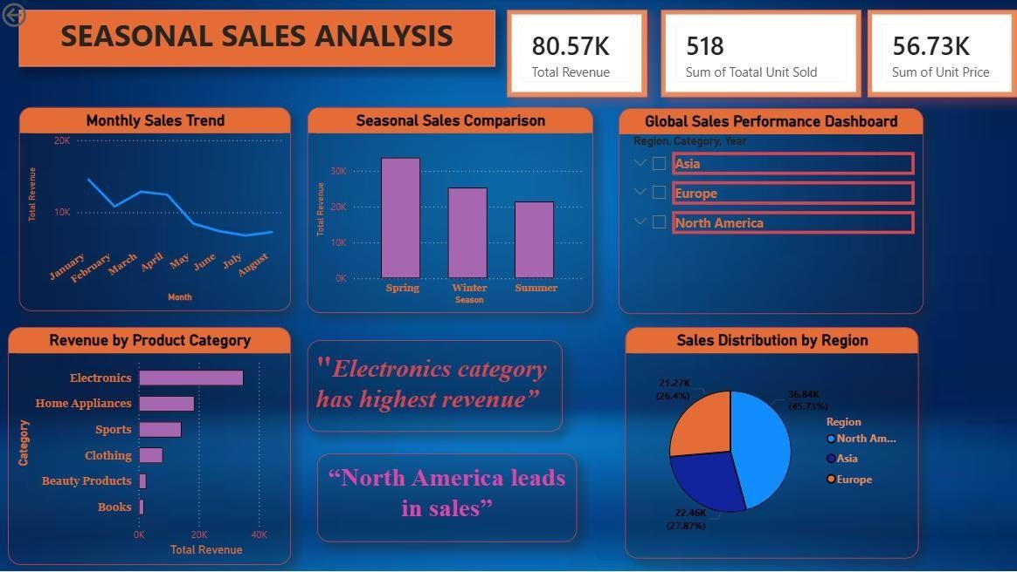
Figure 4 Overview Dashboard

This dashboard presents a comprehensive analysis of seasonal sales performance across different dimensions such as time, category, and region. It highlights key business metrics including total revenue, total units sold, and unit price, providing a clear overview of overall sales performance. The dashboard enables users to understand how sales vary over time and across seasons. The monthly sales trend visualization shows fluctuations in revenue, helping identify peak and low-performing periods. The seasonal comparison further highlights differences in sales across seasons, allowing businesses to recognize patterns in customer demand. Additionally, the category-wise revenue distribution provides insights into which product categories contribute the most to total revenue. The regional sales distribution helps identify geographical performance and key markets driving business growth. Overall, this dashboard acts as a decision-support tool, enabling stakeholders to evaluate performance, identify trends, and make data-driven business decisions.

Details of Visualization used in Overview Dashboard Card – Total Revenue
The card visualization displays the total revenue generated (80.57K). It provides a quick snapshot of overall financial performance and helps stakeholders assess business success.

Card – Total Units Sold
This card represents the total number of units sold (518). It helps in understanding customer demand and overall sales volume.

Card – Sum of Unit Price
This card shows the total unit price value (56.73K), which reflects the pricing contribution to revenue.

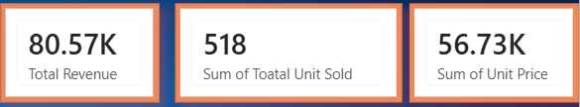
Figure 5 KPI Cards

Line Chart – Monthly Sales Trend
The line chart visualizes revenue trends over months.
- Shows decline after January
- Highlights seasonal fluctuations
- Helps in identifying peak and low sales periods
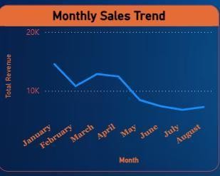
Figure 6 Monthly Sales Trend

Bar Chart – Seasonal Sales Comparison
This chart compares revenue across seasons.
- Spring shows highest sales
- Summer shows lowest performance
- Helps in identifying seasonal demand patterns.

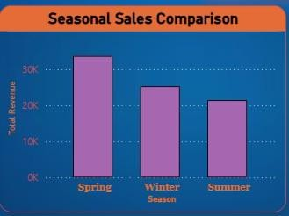
Figure 7 Seasonal Sales Comparison

Bar Chart – Revenue by Product Category
This chart shows revenue contribution of different categories.
- Electronics generates highest revenue
- Books and beauty products contribute least
- Helps in focusing on high-performing categories.
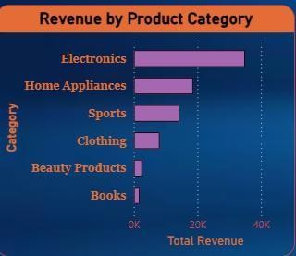
Figure 8 Revenue by Product Category

Pie Chart – Sales Distribution by Region
This chart shows regional contribution to total revenue.
- North America leads
- Asia and Europe follow
- Helps in understanding geographical performance.
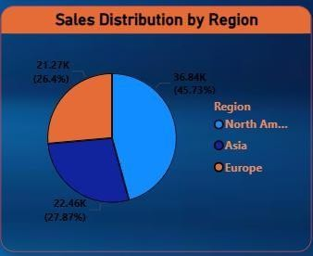
Figure 9 Sales Distribution by Region

Page 2 – Product-Level Analysis Dashboard
This dashboard provides detailed insights into product-level sales performance. It highlights revenue generated by individual products, payment method preferences, and category distribution. The dashboard enables comparison between different products, helping identify high-performing and low-performing items. The payment method analysis provides insights into customer transaction behaviour, while the product count visualization shows category distribution. The inclusion of a detailed data table enhances transparency and allows users to examine individual records. Overall, this dashboard supports better product strategy, inventory management, and pricing decisions.

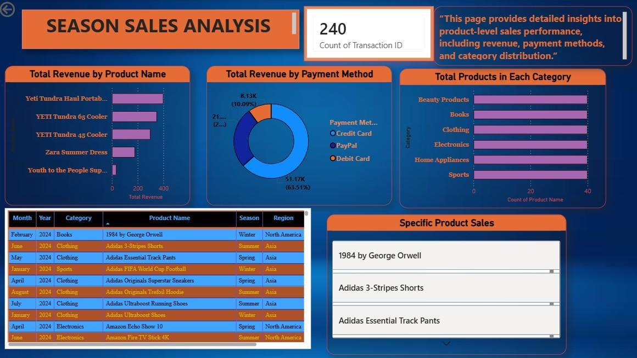
Figure 10 Product-Level Analysis Dashboard

Details of Visualization used in Product-Level Dashboard Bar Chart – Total Revenue by Product Name
This chart displays revenue generated by individual products.
- Identifies top-selling products
- Highlights underperforming products
- Helps in product optimization.
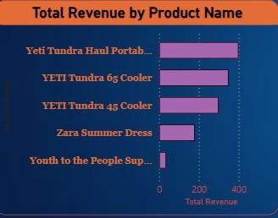
Figure 11 Total Revenue by Product Name

Donut Chart – Total Revenue by Payment Method
This chart shows distribution of payment methods.
- Credit Card dominates (~63%)
- PayPal and Debit Card follow
- Helps understand customer preferences.
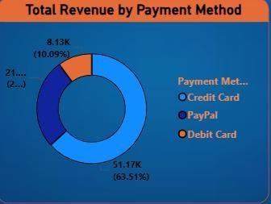
Figure 12 Total Revenue by Payment Method

Bar Chart – Total Products in Each Category
This chart shows number of products per category.
- Helps analyze product distribution
- Supports inventory planning
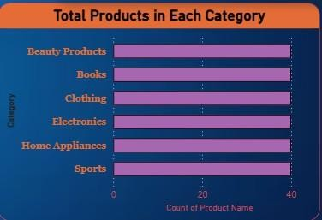
Figure 13 Total Products in Each Category

Table – Sales Data
The table displays detailed transaction data including:
- Month
- Year
- Category
- Product Name
- Season
- Region
- Payment Method
Ensures accuracy and detailed analysis.
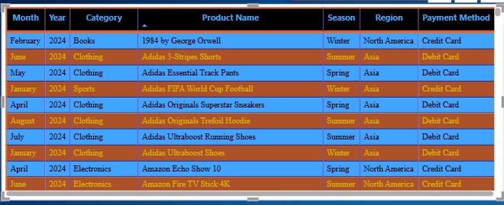
Figure 14 Table – Sales Data

Panel – Specific Product Sales
This section highlights selected products for focused analysis. Helps in understanding product-level performance.
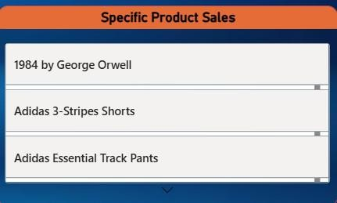
Figure 15 Specific Product Sales

Page 3 – Geographical Sales Distribution
This dashboard provides a geographical representation of sales data using a map visualization. It helps in understanding how revenue is distributed across different regions. The map highlights regions such as North America, Europe, and Asia, showing their contribution to total sales. The size of markers represents the magnitude of revenue, making it easy to identify high-performing regions. This visualization enhances decision-making by providing a clear view of global sales distribution.
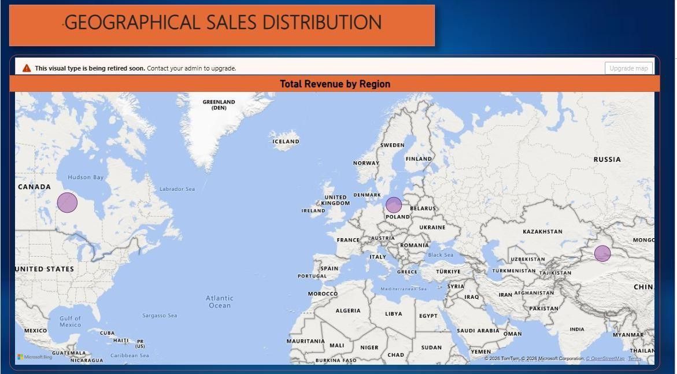
Figure 16 Geographical Sales Distribution

Details of Visualization used in Geographical Dashboard Map – Total Revenue by Region
The map visualizes revenue distribution across different regions.
- Larger bubbles indicate higher revenue
- North America shows highest concentration
- Europe and Asia show moderate performance
- Helps identify key markets and expansion opportunities.

Use of Modern Tools in Implementation
- Analysis
  - Data analyzed using Power BI
  - DAX used for calculations
  - Power Query used for cleaning

Design & Visualization
  - Interactive dashboards created
  - Multiple charts used
  - User-friendly interface

Report Preparation
  - Structured documentation followed
  - Screenshots included
  - Insights explained clearly

Project Management & Communication
  - Work divided into phases
  - Timeline followed
  - Results communicated visually

Testing, Validation & Interpretation Testing
  - Verified calculations
  - Checked visual accuracy

Validation
  - Cross-checked data
  - Ensured consistency

Interpretation
  - Identified trends
  - Derived business insights

Key Insights from Dashboard
  - Sales highest in Spring
  - Electronics category dominates

North America leads in revenue
  - Credit Card is most used payment method
  - Sales decline mid-year

CHAPTER-5 CONCLUSION AND FUTURE WORK

Conclusion
The Seasonal Sales Analysis Dashboard provides a comprehensive and multi-dimensional evaluation of sales performance across time, product categories, regions, and customer behavior. By integrating key performance indicators with temporal and geographical insights, the dashboard offers a structured and data-driven approach to understanding business performance and optimizing decision-making.

Comprehensive Sales Performance Overview
The dashboard highlights key business metrics including:
  - Total Revenue: 80.57K
  - Total Units Sold: 518
  - Sum of Unit Price: 56.73K
These metrics indicate that the business maintains a stable sales performance with consistent demand across multiple product categories. The integration of KPI indicators provides a quick and effective summary of overall performance, enabling stakeholders to monitor business health efficiently.

Seasonal Sales Behaviour and Trends
The analysis of monthly and seasonal trends reveals significant insights into customer purchasing patterns:
  - Peak Performance:
Sales are highest during the Spring season, indicating strong seasonal demand
  - Declining Trend:
A noticeable decline in sales is observed during mid-year months, particularly in Summer
  - Seasonal Impact:
The data confirms that customer purchasing behaviour is highly influenced by seasonal factors
This highlights the importance of aligning marketing strategies and inventory planning with seasonal demand fluctuations.

Category Performance and Product Insights
The category-wise analysis provides a clear hierarchy of product performance:
  - Electronics Category:
Dominates total revenue, indicating high customer demand for technology-based products

  - Home Appliances and Sports:
Show moderate performance and contribute significantly to overall sales
  - Books and Beauty Products:
Represent low-performing categories and may require strategic improvement
At the product level, premium and high-value items generate a larger share of revenue, emphasizing the importance of product positioning and pricing strategies.

Geographical Sales Distribution
The geographical analysis reveals a clear distinction between high-performing and moderate-performing regions:
  - North America:
Leads in total revenue and acts as the primary market
  - Asia and Europe:
Show balanced but comparatively lower performance
This indicates that while the business has a global presence, certain regions contribute more significantly to revenue generation. The map visualization further enhances understanding by clearly highlighting regional performance.

Customer Payment Behaviour
The payment method analysis provides insights into customer transaction preferences:
  - Credit Card: Most preferred method (~63%)
  - PayPal: Moderate usage
  - Debit Card: Least preferred
This suggests that customers prefer faster and more secure digital payment methods, which can guide businesses in optimizing their payment systems.

Overall Business Insights
The dashboard demonstrates that:
  - The business operates in a seasonally influenced market
  - Revenue is driven by specific categories and regions
  - Customer behaviour is influenced by payment convenience and product value
The integration of multiple dashboards ensures that stakeholders can analyze performance from different perspectives, making the system a powerful decision-support tool.

Strategic Recommendations
Based on the analysis, the following strategies are recommended:
- Seasonal Optimization:
Increase marketing efforts during low-demand seasons such as Summer
- Category Focus:
Invest more in high-performing categories like Electronics
- Regional Expansion:
Strengthen presence in Asia and Europe to balance global performance
- Payment Optimization:
Promote digital payment methods through offers and incentives

Future work

Future Work: Advanced Analytics and System Enhancement
While the current system provides strong descriptive analysis, future enhancements can significantly improve its capabilities by incorporating advanced analytical techniques and expanding its functionality.

Predictive Analytics and Forecasting
Future work can focus on predicting future sales trends using advanced techniques:

Time-Series Forecasting:
Predict monthly and seasonal sales patterns

Demand Forecasting:
Estimate future product demand for better inventory management This will help businesses move from reactive to proactive decision-making.

Real-Time Data Integration
The current dashboard is based on static data. Future improvements can include:
  - Integration with live databases and APIs
  - Real-time dashboard updates
  - Continuous monitoring of sales performance
This will improve responsiveness and decision-making speed.

Customer Behaviour Analysis
Future enhancements can include deeper customer insights:
  - Customer segmentation
  - Purchase frequency analysis
  - Customer lifetime value (CLV)
Helps in personalized marketing and customer retention.

Advanced Visualization and AI Integration
  - Use of AI-based insights in Power BI
  - Automated report generation
  - Smart recommendations
Makes the system more intelligent and efficient.

Mobile and Cloud Integration
  - Access dashboard via mobile devices
  - Cloud-based sharing and collaboration Improves accessibility and usability.

Expansion of Dataset
  - Include more years of data
  - Add customer demographics
  - Include external factors like weather and festivals Provides deeper and more accurate analysis.

Long-Term Strategic Roadmap
Phase 1: Optimization (0–6 Months)
  - Improve low-performing categories
  - Increase marketing in low-demand seasons Phase 2: Expansion (6–12 Months)
  - Enter new markets
  - Improve regional performance Phase 3: Automation (12+ Months)
  - Implement AI-based decision systems
  - Automate reporting and analysis

APPENDIX

    - DAX/ Power Queries:

Total Revenue
This measure calculates the total sales revenue generated across all products, categories, and regions. It serves as the primary performance indicator in the Seasonal Sales Analysis dashboard.

DAX Query:

Total Revenue = SUM('Online Sales Data'[Revenue])

Explanation:

The SUM function aggregates all revenue values present in the dataset. In your dashboard, this results in a total revenue of 80.57K. This metric is essential for evaluating overall business performance and identifying which categories and regions contribute the most to sales.

Month
This calculated column extracts the month name from the date field to support time-based analysis and visualization.

DAX Query:

Month = FORMAT('Online Sales Data'[Date], "MMMM")

Explanation:

The FORMAT function converts the date into a readable text format representing the full month name (e.g., January, February). This is used in the Monthly Sales Trend chart, making the dashboard more intuitive and user-friendly.

Month Number
This calculated column generates the numerical representation of the month to ensure correct sorting of month names.

DAX Query:

Month Number = MONTH('Online Sales Data'[Date])

APPENDIX

Explanation:

The MONTH function extracts the numeric value of the month (1–12). This is used to sort the Month column correctly (January to December) instead of alphabetical order, ensuring accurate time-based analysis.

Season
This calculated column categorizes each transaction into a specific season based on the month.

DAX Query:

Season = SWITCH(
TRUE(),
MONTH('Online Sales Data'[Date]) IN {12,1,2}, "Winter", MONTH('Online Sales Data'[Date]) IN {3,4,5}, "Spring", MONTH('Online Sales Data'[Date]) IN {6,7,8}, "Summer", "Autumn"
)

Explanation:

The SWITCH function assigns seasons based on the month value. This classification enables seasonal analysis, which is the core objective of the project. It helps identify patterns such as higher sales in Spring and lower performance in Summer.

Year
This calculated column extracts the year from the date field for yearly analysis.

DAX Query:

Year = YEAR('Online Sales Data'[Date])

Explanation:
The YEAR function extracts the year from the date column. This allows comparison of sales performance across different years and supports time-based filtering in the dashboard.

Roles of Team Members

Collaborative Project Execution & Team Leadership
While Business Intelligence (BI) projects are often distributed across multiple specialized roles such as data engineers, analysts, and designers, this Seasonal Sales Analysis project was executed through a collaborative team effort of three members. Each member contributed to different stages of the development lifecycle, ensuring a balanced combination of technical expertise, analytical thinking, and structured documentation. The team adopted a coordinated approach where responsibilities were divided based on skill sets while maintaining continuous collaboration to ensure consistency and accuracy across all stages of the project.

The Data Engineer: Data Processing & Modeling (Team Member 1)

The first team member was responsible for handling the foundational layer of the project, which includes data preparation, transformation, and modeling.

ETL Processes: Managed the extraction, transformation, and loading (ETL) of the dataset obtained from Kaggle. Ensured that fields such as Revenue, Unit Price, and Total Units Sold were cleaned and structured correctly.

Data Cleaning & Transformation: Used Power Query to remove null values, eliminate duplicates, and standardize data formats. Created derived columns such as Month, Year, and Season for time- based analysis.

Data Modeling: Established relationships between data fields and structured the dataset to support efficient querying and visualization.

The Power BI Developer: Dashboard Design & DAX Implementation (Team Member 2)

The second team member focused on the development of the interactive dashboard and implementation of analytical calculations.

DAX Development: Created key measures such as Total Revenue (80.57K), Total Units Sold (518), and other calculated metrics to support analysis.

Roles of Team Members

Dashboard Design:

Developed multiple dashboards including:

  - Overview Dashboard

  - Product-Level Analysis

  - Geographical Sales Distribution

Visualization & UI Design: Implemented various charts such as line charts, bar charts, pie charts, and map visuals to represent data effectively.

Interactive Features: Added slicers and filters to enable dynamic data exploration and enhance user experience.

This role ensured that the dashboard was visually appealing, interactive, and capable of delivering meaningful insights.

The Business Analyst & Documentation Lead: Insight Generation & Reporting (Team Member 3)

The third team member was responsible for interpreting the data and presenting it in a structured and professional format.

Insight Generation:

Analyzed dashboard outputs to identify key business insights such as:

  - Seasonal trends (Spring as highest revenue season)

  - Category performance (Electronics dominance)

  - Regional contribution (North America leading market)

Strategic Analysis: Translated visual data into actionable business recommendations, such as optimizing marketing strategies during low-demand seasons.

Documentation & Reporting:

Prepared the complete project report, including:

  - Introduction

  - Literature Review

  - Design Flow

  - Results Analysis

  - Conclusion

Presentation & Communication: Ensured that the report and dashboards are understandable for both technical and non-technical stakeholders.

This role ensured that the project outcomes were clearly communicated and aligned with business objectives.

Team Coordination & Quality Assurance

In addition to individual responsibilities, all team members contributed collectively to project management and quality assurance.

  - Data Validation: Cross-checked calculations and ensured accuracy of dashboard outputs

  - Performance Optimization: Ensured smooth functioning of the dashboard and responsiveness of visuals

  - Collaboration: Maintained coordination across all stages to ensure consistency

  - Review & Testing: Verified all components before final submission

Conclusion on Team Roles

This project demonstrates the effectiveness of a collaborative development approach in Business Intelligence systems. By dividing responsibilities among data engineering, dashboard development, and

business analysis, the team ensured that every aspect of the project—from raw data processing to final insight generation—was handled with precision and expertise. The integration of technical implementation with strategic analysis resulted in a comprehensive and cohesive dashboard that not only visualizes data but also supports informed decision-making and business growth.

Git repository Link

LINK: https://github.com/vikash1848/Seasonal-Sales-Analysis-Dashboard
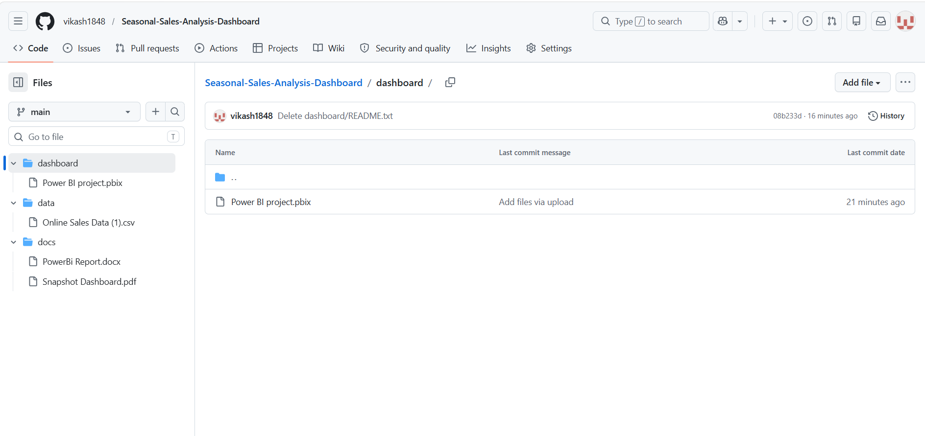
Figure 17 Snapshot of repository

